Ideation Phase
Define the Problem Statements

Date | 06 February 2026
Team ID | LTVIP2026TMIDS80676
Project Name | FreelanceFinder: Discovering Opportunities, Unlocking Potential
Maximum Marks | 2 Marks

Customer Problem Statement Template:
The freelancing process is often fragmented across multiple platforms, making it difficult for clients and freelancers to manage projects efficiently. Freelancers struggle to find reliable opportunities and track their submissions, while clients face challenges in monitoring proposals and communication. Existing systems can be complex and lack a simple, centralized workflow. There is a need for a secure and user-friendly platform that integrates project posting, proposal management, and work submission in one place. The FreelanceFinder project aims to solve these issues by providing a streamlined and organized freelancing environment.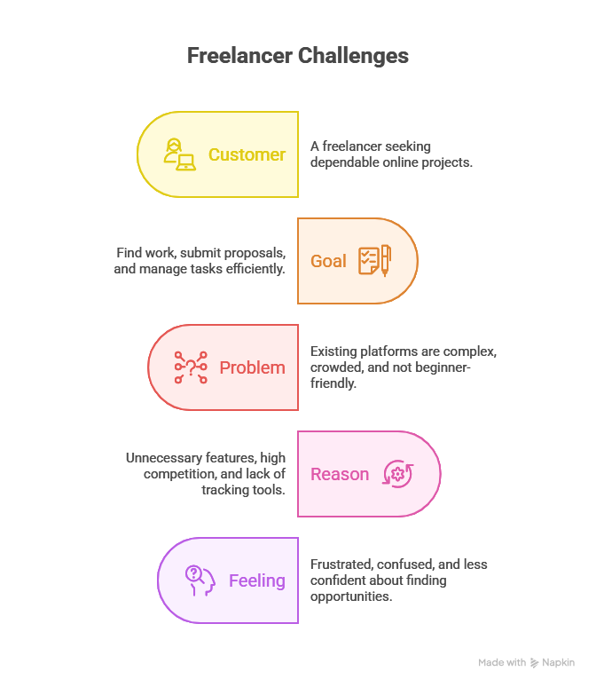

Example:
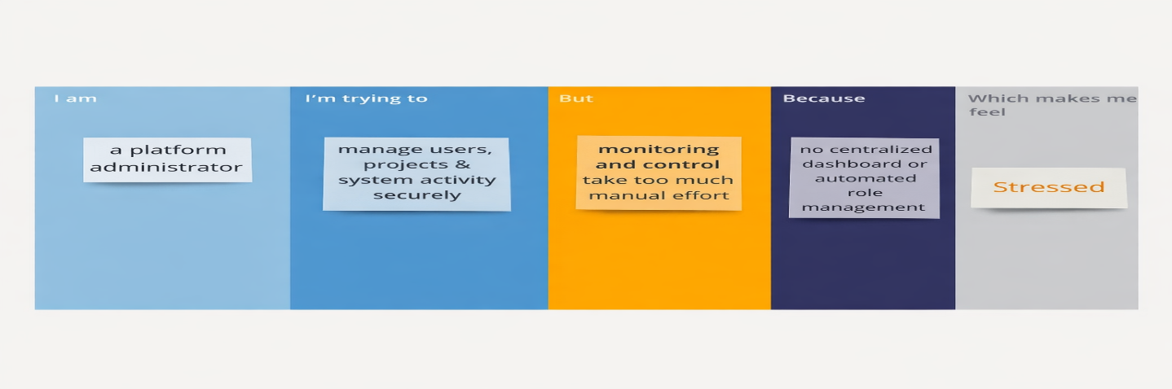
Problem Statement (PS) | I am (Customer) | I’m trying to | But | Because | Which makes me feel
PS-1 | A freelancer looking for reliable projects online. | Find suitable work opportunities, submit proposals, and manage my tasks efficiently in one place. | Many existing platforms are complex, crowded, or not beginner-friendly for students and new freelancers. | They include unnecessary features, high competition, and lack simple project tracking tools. | Frustrated, confused, and less confident about finding genuine opportunities.
PS-2 | A platform administrator or system manager. | Maintain secure user access, manage project data, and monitor system activities efficiently. | Manual monitoring and lack of centralized control make it difficult to manage users and submissions. | Traditional systems lack automated workflows and structured role-based management. | Stressed about maintaining platform security and performance.

